

American International University-Bangladesh (AIUB)
Department of Computer Science Faculty of Science & Technology (FST)
PROJECT TITLE
Society Problem Reporter and Analyzer
Submitted By
GROUP G

Semester-->Summer-25-26 |  | Section:DD
 | Student Name | Student ID
 | 24-58774-2 | Jami-Ul-Mashrur
 | 23-55359-3 | Anique Kumar Das
 | 24-59609-3 | Sabuj Kumar Paul
 | 24-57690-2 | Syndid Chowdhury

Table of Contents
• Introduction
- 1.1 Purpose
- 1.2 Scope
- 1.3 Intended Audience
- 1.4 Document Overview
• Overall Description
- 2.1 Product Perspective
- 2.2 Product Functions
- 2.3 User Classes
- 2.4 Operating Environment
- 2.5 Assumptions and Dependencies
- Figure 2.1: System Context Diagram
• User Stories
- User Story table
- Developer's Acknowledgement/Justification
- Priority
• Functional Requirements
- Functional Requirements table
- Figure 4.1: ER Diagram
• Non-Functional Requirements
- Non-Functional Requirements table
• Use Case Diagram
- Brief description
- Figure 6.1: Use Case Diagram
• Requirements Traceability Matrix (RTM)
- Mapping between Functional and Non-Functional Requirements

Chapter 1: Introduction

1.1 Purpose
The purpose of this Software Requirements Specification (SRS) is to define the functional and non-functional requirements of the Society Problem Reporter and Analyzer. This document serves as a guide for developers, testers, and stakeholders to understand the system's objectives, features, and expected behavior during development.

1.2 Scope
The Society Problem Reporter and Analyzer is a web-based application designed to help citizens report community problems and assist local authorities in resolving them efficiently. The scope of the system includes:
- Allow citizens to register, log in, and submit reports about community issues.
- Enable users to upload images, specify locations, and track the status of their reports.
- Allow community members to vote on reported issues so that urgent problems receive higher priority.
- Provide local authorities and administrators with tools to manage reports, update their status, and monitor community issues.

1.3 Intended Audience
This document is intended for:
- Developers – To understand the system requirements and implement the application.
- Project Supervisor – To review and evaluate the proposed system.
- Testers – To verify that the system meets the specified requirements.
- Project Team Members – To ensure everyone has a common understanding of the project.

1.4 Document Overview
This SRS describes the overall requirements of the Society Problem Reporter and Analyzer. It includes the system overview, user stories, functional requirements, non-functional requirements, use case diagram, requirements traceability matrix, and conclusion.

Chapter 2: Overall Description

2.1 Product Perspective
The Society Problem Reporter and Analyzer is a web-based application designed to bridge the communication gap between citizens and local authorities. It allows users to report community problems, track their status, and receive updates. Authorities can review reports, prioritize issues, and update their resolution status through a centralized dashboard.
Figure 2.1: System Context Diagram
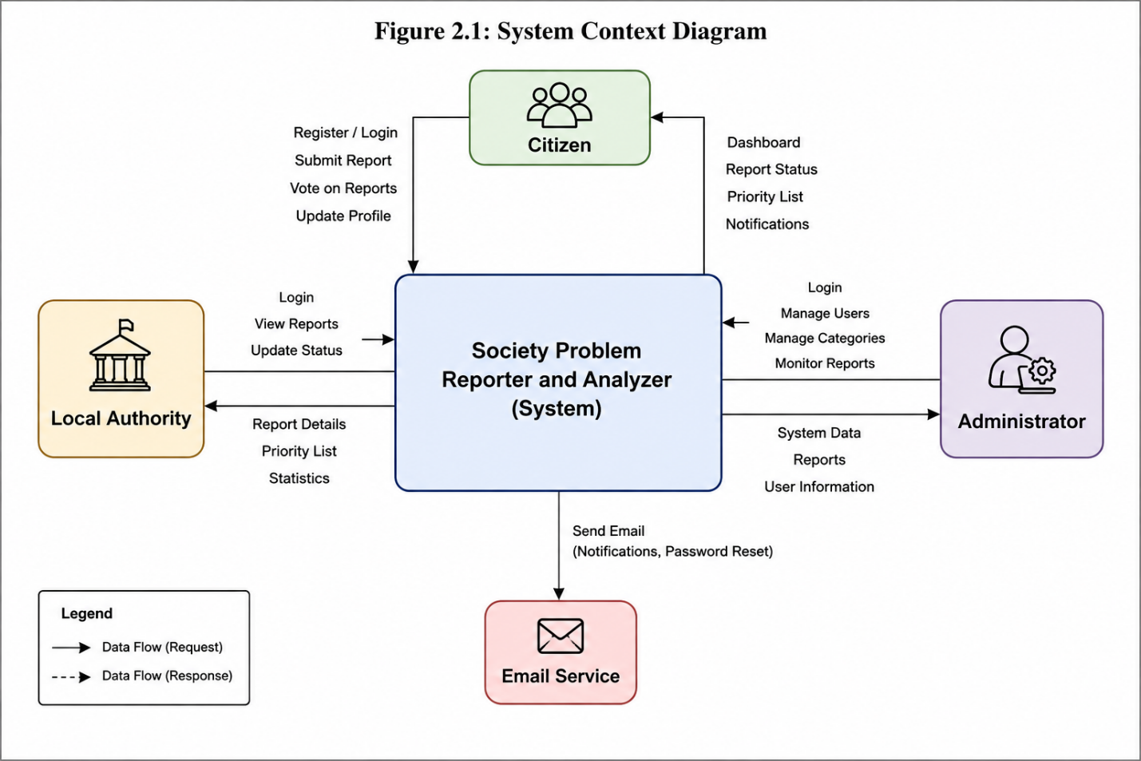

2.2 Product Functions
The main functions of the system are:
- User registration and login.
- Submit reports with descriptions, images, and locations.
- View and track submitted reports.
- Vote on reported issues to increase their priority.
- Update report status by local authorities.
- Manage users and reports by the administrator.
- Send notifications for report updates.

2.3 User Classes
The system has three types of users:
User | Responsibilities
Citizen | Register, log in, submit reports, vote on reports, and track report status.
Local Authority | View reports, update report status, and manage assigned issues.
Administrator | Manage users, monitor reports, and maintain the overall system.

2.4 Operating Environment
The system is a web-based application that can be accessed using modern web browsers such as Google Chrome, Mozilla Firefox, Microsoft Edge, and Safari. It supports Windows, Linux, macOS, Android, and iOS devices with an internet connection.

2.5 Assumptions and Dependencies
- Users have a stable internet connection.
- Citizens provide accurate information while submitting reports.
- Local authorities regularly monitor and update report statuses.
- The system relies on a database server to store user and report information.

Chapter 3: User Stories
User stories describe the system requirements from the perspective of the end users. The developer's acknowledgement explains how each requirement will be addressed during system development.
User Story ID | User Story | Developer's Acknowledgement / Justification | Priority
US-01 | As a Citizen, I want to register an account so that I can access the system and report community problems. | The system will provide a registration page with input validation and unique email verification to ensure secure account creation. | High
US-02 | As a Citizen, I want to log in securely so that I can access my account and manage my reports. | The system will authenticate users using their registered credentials and provide role-based access after successful login. | High
US-03 | As a Citizen, I want to submit a report with a title, description, category, location, and image so that the relevant authority can review the issue. | The system will provide a report submission form that stores all report details in the database and associates the report with the logged-in user. | High
US-04 | As a Citizen, I want to track the status of my submitted reports so that I know the progress of the reported issue. | The system will display the current status of each submitted report and update it whenever the authority changes the report status. | High
US-05 | As a Citizen, I want to vote on existing reports so that important community problems receive higher priority. | The system will allow authenticated users to vote once per report and use the total vote count to assist in prioritizing reported issues. | Medium
US-06 | As a Local Authority, I want to view all assigned reports so that I can review and resolve community issues efficiently. | The system will provide an authority dashboard where reports can be viewed, filtered, and managed based on category and status. | High
US-07 | As a Local Authority, I want to update the status of reports so that citizens are informed about the progress of their complaints. | The system will allow authorities to change report statuses (e.g., Under Review, In Progress, Resolved) and automatically notify the respective users. | High
US-08 | As an Administrator, I want to manage user accounts and reports so that the system remains organized and secure. | The system will provide administrative tools for managing users, monitoring reports, and maintaining overall system integrity. | High
US-09 | As an Administrator, I want to monitor system activities so that misuse, spam, or inappropriate content can be identified and addressed. | The system will maintain activity logs and provide monitoring features that help administrators oversee platform usage and take corrective actions when necessary. | Medium

Chapter 4: Functional Requirements
Functional requirements describe the core features and services that the Society Problem Reporter and Analyzer must provide to its users.
Requirement ID | Functional Requirement | Description
FR-01 | User Registration | The system shall allow new users to create an account.
FR-02 | User Login | The system shall authenticate registered users before granting access.
FR-03 | Submit Report | Users shall be able to submit community problem reports with a title, description, category, location, and image.
FR-04 | View Reports | Users shall be able to view their submitted reports and their current status.
FR-05 | Vote on Reports | Citizens shall be able to vote on reported issues to increase their priority.
FR-06 | Update Report Status | Local authorities shall be able to update the status of reported issues (e.g., Under Review, In Progress, Resolved).
FR-07 | Search and Filter Reports | Users shall be able to search and filter reports based on category, location, or status.
FR-08 | Notification Management | The system shall notify users whenever the status of their reports changes.
FR-09 | User Management | Administrators shall be able to manage user accounts and monitor reports.
FR-10 | Logout | The system shall allow users to securely log out of their accounts.

Figure 4.1: Entity Relationship (ER) Diagram
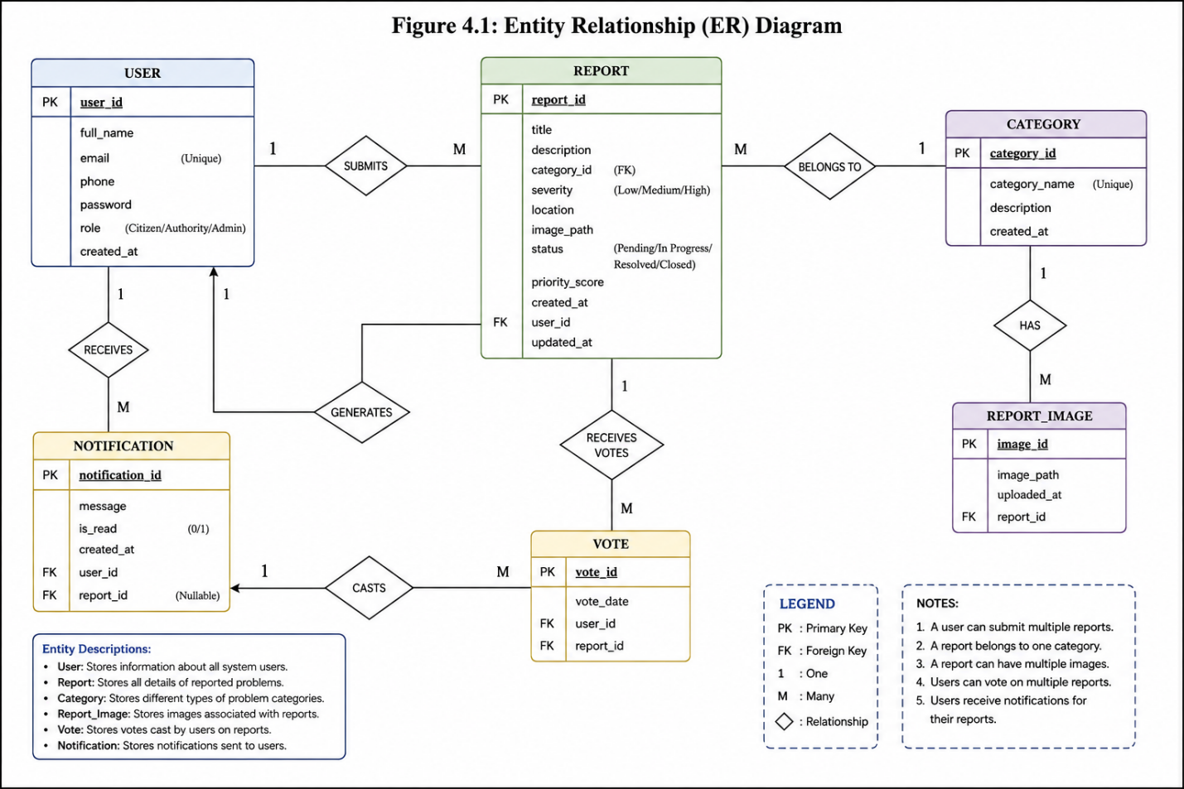
Figure 4.1 illustrates the relationships among the main database entities, including User, Report, Vote, and Notification. It shows the primary keys, foreign keys, and associations used to manage system data efficiently.

Chapter 5: Non-Functional Requirements
Non-functional requirements describe the quality attributes and performance standards that the Society Problem Reporter and Analyzer must meet to ensure a reliable, secure, and user-friendly system.
Requirement ID | Non-Functional Requirement | Description
NFR-01 | Performance | The system shall load pages within 3 seconds under normal network conditions.
NFR-02 | Security | The system shall authenticate users, encrypt passwords, and restrict access based on user roles.
NFR-03 | Reliability | The system shall store reports accurately and ensure data is not lost during normal operation.
NFR-04 | Availability | The system shall be available 24/7 except during scheduled maintenance.
NFR-05 | Usability | The system shall provide a simple, responsive, and user-friendly interface.
NFR-06 | Maintainability | The system shall be modular and easy to update or maintain.
NFR-07 | Scalability | The system shall support an increasing number of users and reports without significant performance degradation.
NFR-08 | Compatibility | The system shall work on modern web browsers and common operating systems.

Chapter 6: Use Case Diagram

6.1 Use Case Diagram
The Use Case Diagram illustrates the interactions between the primary actors and the Society Problem Reporter and Analyzer system. It shows the main functionalities available to Citizens, Local Authorities, and Administrators, providing a high-level overview of the system's behavior.

Figure 6.1: Use Case Diagram
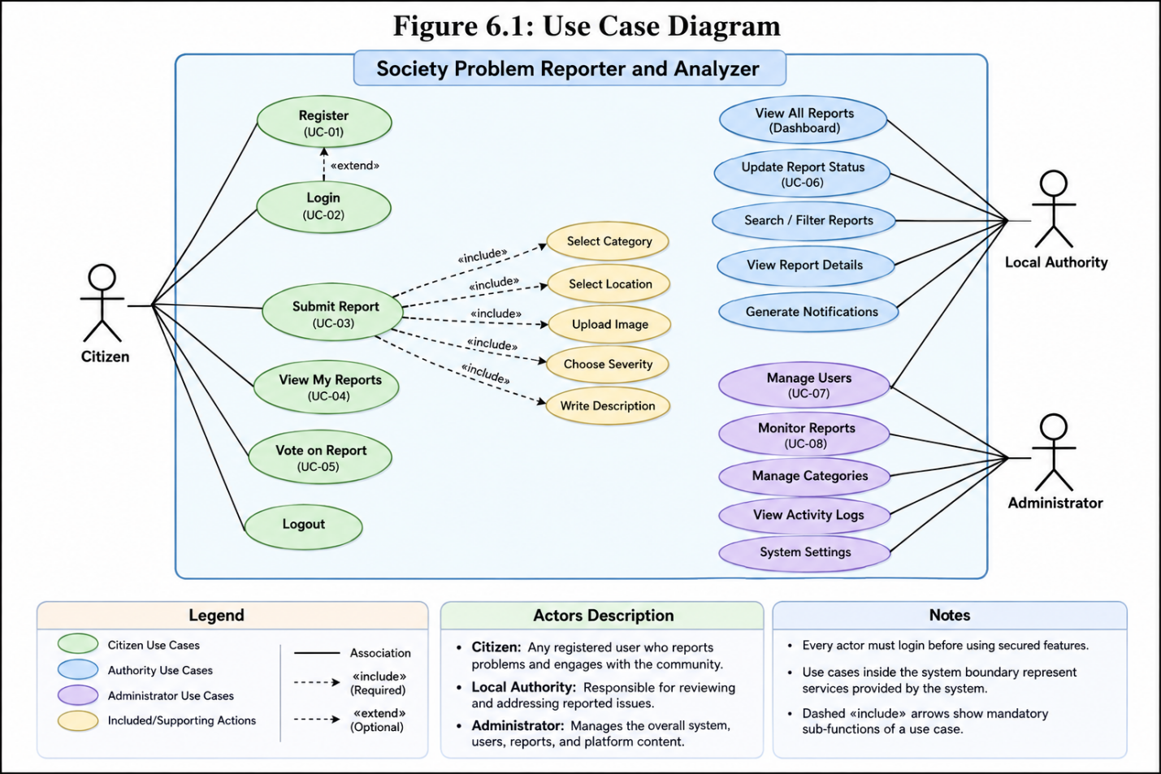
Figure 6.1 illustrates the interactions between the three primary actors—Citizen, Local Authority, and Administrator—and the major functionalities of the system. Citizens can register, log in, submit reports, view report status, and vote on community issues. Local Authorities can review reports and update their status, while Administrators are responsible for managing users and monitoring reports to ensure the smooth operation of the platform.

Chapter 7: Requirements Traceability Matrix (RTM)
The Requirements Traceability Matrix maps the functional requirements to the related non-functional requirements to ensure that all system requirements are addressed during development and testing.
Functional Requirement | Related Non-Functional Requirement(s)
FR-01 User Registration | NFR-02 Security, NFR-05 Usability
FR-02 User Login | NFR-02 Security, NFR-01 Performance
FR-03 Submit Report | NFR-01 Performance, NFR-03 Reliability
FR-04 View Reports | NFR-01 Performance, NFR-05 Usability
FR-05 Vote on Reports | NFR-01 Performance
FR-06 Update Report Status | NFR-03 Reliability, NFR-04 Availability
FR-07 Search and Filter Reports | NFR-01 Performance, NFR-05 Usability
FR-08 Notification Management | NFR-04 Availability
FR-09 User Management | NFR-02 Security, NFR-06 Maintainability
FR-10 Logout | NFR-02 Security

